Absolutely. Since this is a 10-mark exam question, I would not keep the original guide that long. Below is a proper exam-oriented note using your technical terms, but removing unnecessary details and repetition.

7.2 Cloud OS: Kubernetes and OpenStack

1. Definition
Cloud Operating System (Cloud OS): A system that manages and abstracts compute, storage, and networking resources across distributed data-center machines.
- Kubernetes (K8s): An open-source container orchestration platform that automates deployment, scaling, resource allocation, and management of containerized workloads.
- OpenStack: An open-source IaaS cloud platform used to manage virtualized compute, storage, and networking resources.

2. Architecture and Resource Management

A. OpenStack Architecture
OpenStack manages physical infrastructure through modular services:
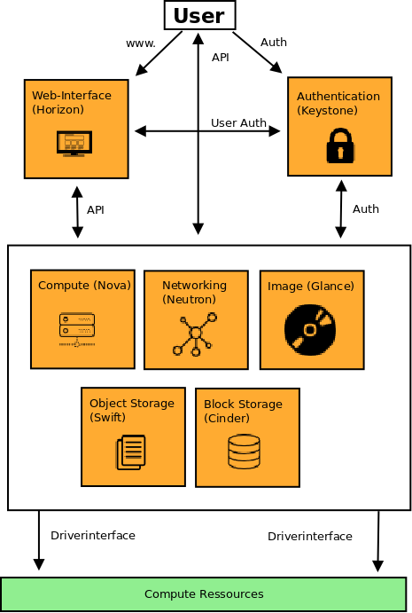
Service | Function
Nova | VM creation, lifecycle and scheduling
Neutron | Virtual networking, IPs and routing
Cinder | Persistent block storage
Swift | Object storage
Glance | VM image management
Keystone | Authentication and authorization
Horizon | Web-based dashboard
Resource Management:
OpenStack uses hypervisors such as KVM to virtualize CPU, RAM, storage and networking into multi-tenant VM environments.

B. Kubernetes Architecture
Kubernetes manages containers across a cluster.
Control Plane:
- API Server – handles requests.
- Scheduler – assigns Pods to suitable nodes.
- Controller Manager – maintains desired state.
- etcd – stores cluster state.
Worker Node:
- Kubelet – manages Pods on the node.
- Kube-Proxy – handles network communication.
- Container Runtime – executes containers.
- Pods – smallest deployable units containing containers.
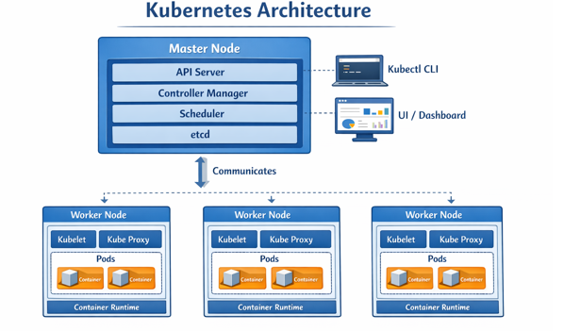
Resource Management:
Kubernetes uses automatic scheduling/bin packing based on CPU and memory requirements. cgroups control resources, while namespaces provide process and network isolation.

3. Kubernetes vs OpenStack
Feature | OpenStack | Kubernetes
Main Goal | IaaS infrastructure management | Container orchestration
Unit | Virtual Machine | Pod/Container
Compute | Nova + Hypervisor | Scheduler
Storage | Cinder / Swift | Persistent Volumes
State | SQL database | etcd
Networking | Neutron | Kube-Proxy / CNI
Main Benefit | Multi-tenant infrastructure | Automatic scaling & self-healing

4. Fault-Tolerance Techniques
Fault tolerance allows a distributed system to continue operating despite component failures.

1. High-Availability Clustering
- Uses primary and standby nodes.
- If the primary fails, the standby takes over.
- Improves availability and reliability.

2. Replication
- Maintains multiple copies of services/data.
- Active replication: replicas process requests simultaneously.
- Passive replication: backup remains ready to take over.

3. Self-Healing
Kubernetes uses health probes to detect failed containers and automatically restart or replace them.

4. Live Migration
- Moves an active VM from one physical node to another.
- Helps during hardware failure, maintenance, and load imbalance.

5. Load-Balancing Techniques
Load balancing distributes workloads among servers/nodes to avoid overload and improve resource utilization and performance.

A. Static Load Balancing
1. Round Robin
- Requests are distributed sequentially.
- Simple, but does not consider server workload.
2. Weighted Round Robin
- Assigns more requests to powerful servers using weights.
3. Source IP Hash
- Maps a client to a server using its IP address.
- Helps maintain session persistence.

B. Dynamic Load Balancing
1. Least Connection
- Sends new requests to the server with the fewest active connections.
2. Push Migration
- Overloaded node pushes tasks to an idle node.
3. Pull Migration / Work Stealing
- Idle node pulls tasks from a busy node.
Or

A. Static Load Balancing

1. Round Robin
- Working: Requests are distributed sequentially among servers.
- Advantage: Simple, fast, and has low overhead.
- Limitation: Does not consider server workload or capacity.

2. Weighted Round Robin
- Working: Assigns more requests to powerful servers using predefined weights.
- Advantage: Provides better resource utilization when servers have different capacities.
- Limitation: Requires proper weight configuration and does not adapt well to changing workloads.

3. Source IP Hash
- Working: Maps a client to a server using its IP address.
- Advantage: Maintains session persistence.
- Limitation: May cause uneven load if many clients map to the same server.

B. Dynamic Load Balancing

1. Least Connection
- Working: Sends new requests to the server with the fewest active connections.
- Advantage: Adapts to the current server load and reduces overload.
- Limitation: Requires continuous monitoring of active connections.

2. Push Migration
- Working: An overloaded node pushes tasks to an idle or lightly loaded node.
- Advantage: Quickly reduces the load on overloaded nodes.
- Limitation: Generates communication and task-transfer overhead.

3. Pull Migration / Work Stealing
- Working: An idle node pulls tasks from a busy node.
- Advantage: Efficient for dynamically changing workloads and improves resource utilization.
- Limitation: Requires coordination and communication between nodes.

6. Layer 4 vs Layer 7 Load Balancing
Layer 4 | Layer 7
Uses IP and TCP/UDP ports | Uses application-level information
Faster and simpler | More intelligent and flexible
Does not inspect application content | Inspects HTTP headers, URL, cookies, etc.
Lower processing overhead | Higher processing overhead

7. Contribution to Distributed Systems
Mechanism | Main Contribution
Resource Scheduling | Better resource utilization
Load Balancing | Prevents overload and improves performance
Replication | Improves reliability
Self-Healing | Automatic failure recovery
Live Migration | Maintains availability and balances load
Auto Scaling | Handles changing workloads
Clustering | Provides high availability

8. Advantages

Kubernetes
- Automatic scaling
- Self-healing
- Efficient container utilization
- Rolling updates
- Suitable for microservices

OpenStack
- Multi-tenant infrastructure
- Flexible and modular architecture
- Virtualizes compute, storage and networking
- Suitable for private and public IaaS clouds

9. Key Challenges
- Kubernetes: Complex cluster management, networking and configuration.
- OpenStack: Complex deployment, maintenance and infrastructure requirements.
- Distributed systems: Network latency, node failures, synchronization, consistency and load imbalance.

10. Conclusion
Conclusion: Cloud OS manages distributed compute, storage, and networking resources efficiently. OpenStack focuses on IaaS and VM management, while Kubernetes focuses on container orchestration. Fault tolerance, load balancing, and automatic scaling improve reliability, scalability, resource utilization, and performance.

